**General analysis and foundations for Pork Chop Express, (Gem Bar and Dining) Review.**

**Initial Summary:**

The data review suggest current offerings are all losing money based on the initial financial analysis. This is not great news but hardly surprising given the overall financial position of Gem. Some options are performing better than others, the best option for Gem at present is to host a band night. Further analysis can be undertaken around each band or non band night, this has identified the most obvious overall trends but is by no means a comprehensive list. We have aimed to highlight the most relevant factors. The main assumptions we are making are based on the current data undertakings and what information we currently have available.

1. **Our main assumptions in this initial overview are:**

* 33% wage split towards costs for non band nights vs 66% towards band nights.
* Food accounts for 15% revenue evenly split across band and non-band nights. Our local attempt (getting data off POS system directly) was not a success so we have calculated all
* figures off available xero data & bank statements to this point.
* As we do not have complete POS data at this point, bank statement data was used to match revenue to a particular day, cost averages have been applied across the month and averaged in a data conscious manner, but we have not tied individual band prices to an individual performance at this point, rather we have taken all band costs for a month and averaged them out across when a given band was playing. We manually mapped when a band was playing based on Gem Bar’s advertised ‘gig guide’ based on Instagram posts for each relevant month in question. This gave us an accurate portrayal of when revenue occurred, but as mentioned costings are only averaged.

1. 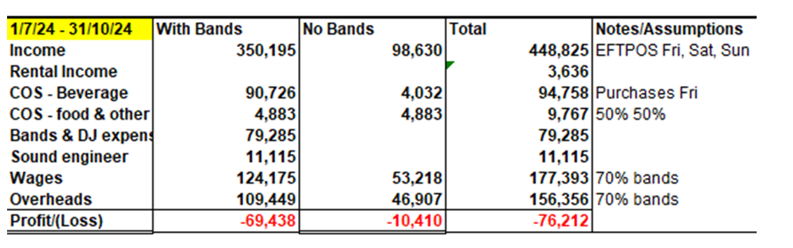**High level analysis based on system review, dates subsequently found not exact but shows overall trends.**

Le’s overarching review summary above is based upon a high level review of revenue, COGS & expenses. Analysis below is used to establish a baseline and give indication of what’s going on, numbers are relative above and below, based on our given assumptions. While totals are accurate based on bank feed data and the relevant Xero accounts we are making educated data driven guesses at this point on the exact costing compositions. Note I wanted to show the above as at present based on our assumptions some slightly different answers/overall figures are obtained for bands vs no bands, but trends remain constant.

1. **What does the revenue generation look like:**

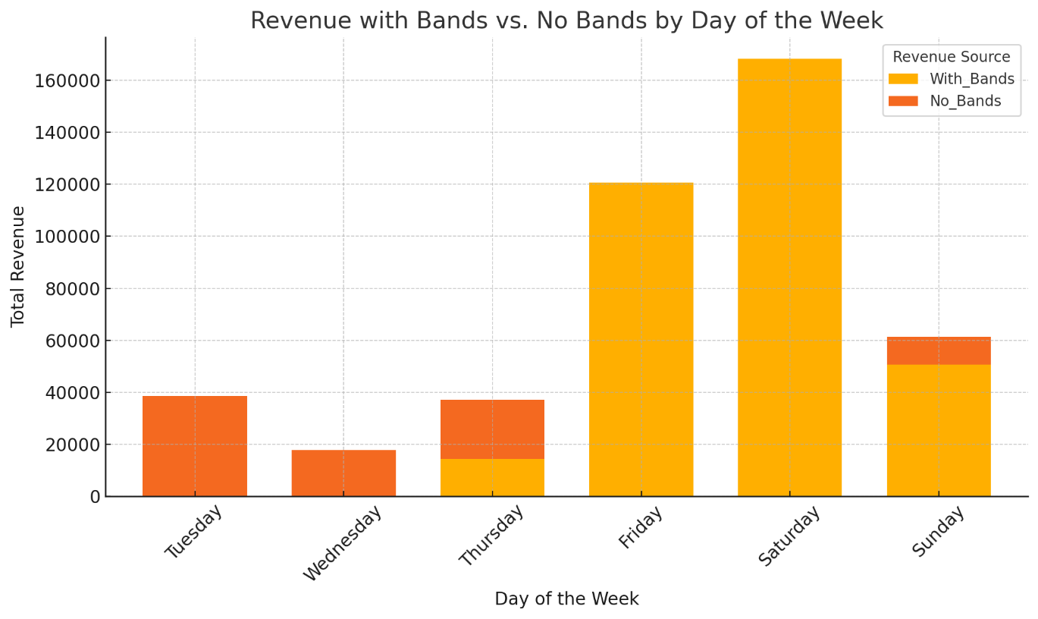Revenue generation for days of the week **July24-October 24.**

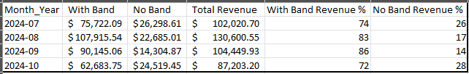**Breakdown per month of revenue generation.**

* Band nights are generating the most revenue across all months this financial year at a ratio of 3:1, but have higher expenses which we will come to later.
* There is some fluctuation in band revenue to No Band Revenue, September for instance has a very high band revenue proportion, this can be examined further.
  + Further analysis could also be undertaken to determine the effects each individual months revenue mix had on underlying profit figures.
  + This can be generalised for now through referencing the daily profits/losses for each day type (see point 7).

1. 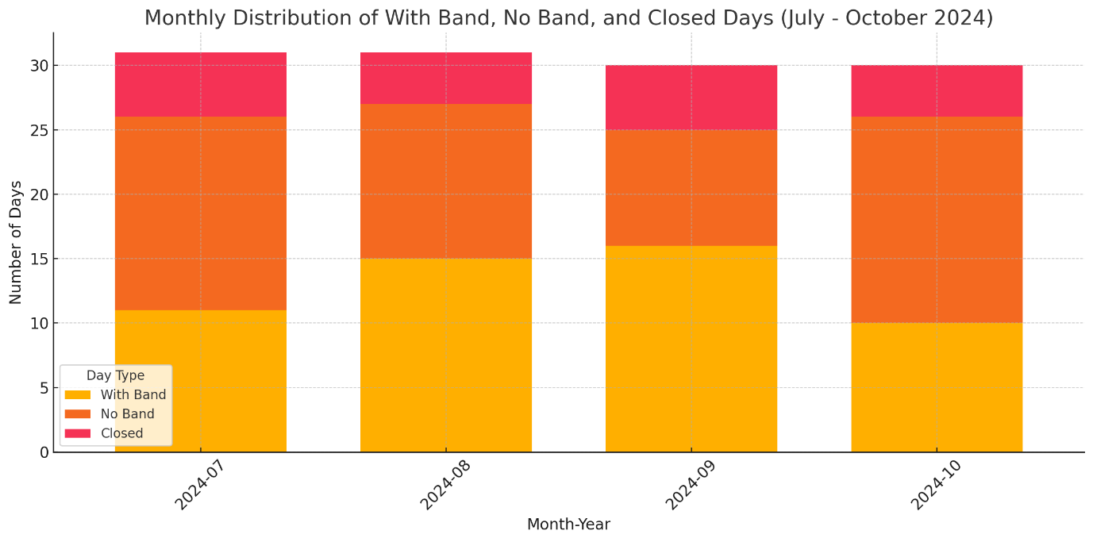**Monthly Distributions of Band Nights, No Band Night or Closed (generally Gem is closed on a Monday so far this FY).**

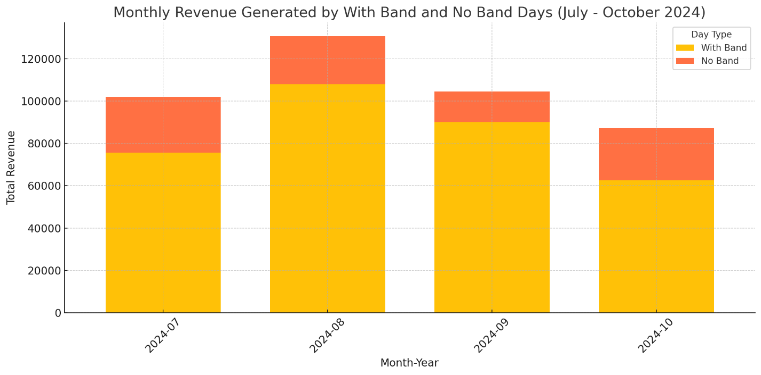**5. Revenue type generation (Band or No Band) by month.**

**6. Expenses & COGS attributions.**

* Some more relevant assumptions, Beverage prices for COGS, we are assuming costs proportionate to revenue generation for alcohol, the average of the 4 months nights **with band revenue** is responsible for = 78.75% of alcohol revenue and therefore for the same proportion of COGS for alcohol.

Other expenses are apportioned fairly based on relevant weight. The Spreadsheets can be looked at in more depth and wages split 33% non band to 66% band nights. In short band nights it would appear are not hurting as much as non-band nights. A key standout and point of interest is that Monday closures relate to a $64k loss this FY if the trend continues. Costs have been attributed as if Monday is responsible (rightly) for the proportionate amount of each relevant overhead each month.

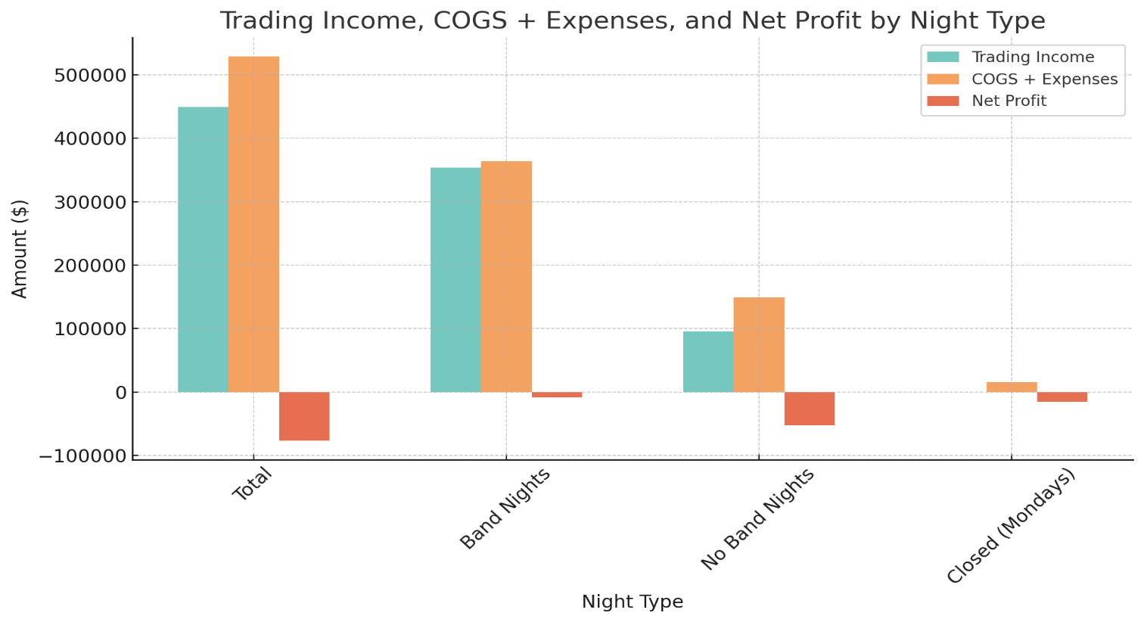See ***Profit_and_LossReview ft assumptions total excel document for a further breakdown. Below graph charts the 4 months until end of October 24 (July-Oct).***

**7. Important to note: Daily Losses at present.**

Operating costs per day throughout this 4 month period based on each offering/day type are given below. This metric is key to understand what it’s costing Gem on an individual level to operate.Note this is under the assumption of labour cost attributions at 66% band nights and 33% non band nights. This is once again are worth reiterating, as it will modify the below result figures if analysis determines different wage attributions are needed.

|  |  |  |  |  |
| --- | --- | --- | --- | --- |
|  | **Jul-Oct 2024 Total** | Band Nights | No Band Nights | Closed (Mondays) |
| **Total days throughout this period for each type.** | 122 | 52 | 52 | 18 |
| **Daily loss currently per day type** | -$ 624.69 | -$ 166.71 | -$ 1,004.71 | -$ 849.88 |

* **Daily Losses. In short.**
  + ‘No band nights’ are sending Gem in arrears approximately $1000 on each occasion.
  + Being closed (Mondays) is financially costly, losing on average throughout the 4 month period of $850 for each occurrence.
  + Band nights are only losing approx. $165 each occurrence.
  + On average Gem are going backward by $625 daily under current configurations.

**8. Other General insights from the Profit and Loss Review. What’s going on.**

Income Analysis

* Band Nights account for a significant portion of income ($353,449.64), approximately 79% of the total income.
* No Band Nights contribute about 21% ($95,375.30) of the total trading income.
* Closed Days do not generate any trading income

Cost of Sales

* **Total Cost of Sales** for the period is $104,525, with **Band Nights** bearing the majority of the cost at **75%** ($78,748.45).
* **Beverage Costs** represent the highest cost within this category, especially on Band Nights ($74,621.95), indicating that beverage sales are a key revenue driver on Band Nights.

Gross Profit

* **Total Gross Profit** for the period is $344,300.
* Band Nights contribute the highest gross profit ($274,701), which is **about 80%** of the total gross profit, reflecting the strong revenue generated on these nights.
* No Band Nights generate a gross profit of $69,599, approximately **20%** of the total.

Operating Expenses

* **Total Operating Expenses** for the period amount to $424,148.12.
* The largest expense categories are **Wages and Salaries** ($159,380.71) and **Band & DJ Expenses** ($79,285), with most of these expenses incurred on Band Nights.
* Expenses related to **Cleaning, Hotel Supplies (Food), Rent, and Superannuation** are also substantial.
* **Closed Days** have minimal operating expenses, mainly related to rent and fixed expenses.

Net Profit

* **Overall Net Loss** for the period is $76,212.
* **Band Nights** show a slight loss of $8,669, but this is much lower than the losses on **No Band Nights** ($52,245). Although this could be influenced strongly either direction pending exact wage breakdown / allocations.
  + This would need to be explored further.
* **Closed Days** also show a loss ($15,298), reflecting ongoing fixed costs that persist even when the business is closed.

Key Takeaways

* **Band Nights** drive the majority of revenue and cover a large proportion of both variable and fixed expenses.
* **Fixed Costs** (like rent, insurance, and some utilities) significantly impact the bottom line on closed days, highlighting the importance of maximising income on open days to offset these costs.

**Revenue deductions after this initial investigation.**

* **Currently 2 revenue drivers only.**
* **Food and drink.**
  + Revenue maximisation is occurring on Band Nights: Band Nights are the largest revenue days but also incur higher costs, namely band & sound fees + wages. The strategy of using Band Nights to attract more customers is successful in terms of revenue generation but not bottom line. **Although as noted above they’re the best financial performer at present.**
  + **Food and Beverage** are consistent sellers: Food sales are steady across Band and No Band Nights, but beverages spike on Band Nights, highlighting the impact of entertainment on drink sales.
    - This is our assumption of an even split on food allocations, actual data important here, as are cost implications of taking a cut of new food operators coming in. We need to determine what other expenses are associated with the food service offering, this may result in the trimming down of some of the wages going forward for instance if staff participated in getting food out etc.
  + Fixed Costs Burden on Closed Days: Rent, utilities, and insurance continue to incur costs on Closed Days, impacting profitability. What can be done about the down day, needs to be explored.
  + Ticket sales to be explored as I know Gem are already looking into it to add another revenue stream and help offset the high costs of hosting bands.
    - Without this the only way to improve bottom line is to increase sales (drinks largely), paly with the food offerings (which we know is being looked at) or significantly cut costs.

**9. Next steps – from the data review.**

* Full financial dashboard functionality for up to date metrics on how Gem/Pork Chop is tracking with key metrics.
  + So owners/operators know their exact standing at any time, that is up to date based on current Xero data feeds.
* Wage/staffing review, when exactly are staff being paid and how much revenue is Gem bringing in on those nights.
  + How much does gem need to earn each night based on staffing to make the desired amount of profit.
* What Band nights are the most profitable, what is the optimal number of nights to host per month and which nights should Gem host.
* Seasonality analysis to predict changes that need to be made and their magnitude.
  + We’re coming into the festive season and good weather, expected bump in general revenue but we need to ensure costs are not also rising and Gem can make a profit.
* Budget creation after further analysis so targets can be adhered to and a product / operations strategy can be put in place to achieve the targets needed to ensure Gem can be made financially viable.